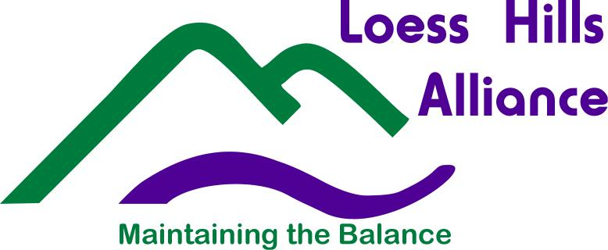
Please Check Appropriate Category _____ K-3 _____ 4-6 _____ 7-12
Complete the form neatly by printing or typing, attach to the back of poster entry, and submit to the respective location in your county in which your school is located. (See locations below) Deadline: Received by 4:00pm on Friday, September 22, 2017.

2017 Loess Hills Heritage Poster Contest
Theme: “Living in the Loess”

STUDENT INFORMATION:
First Name _______________________ Middle Initial ______ Last Name __________________________________
Address ______________________________________________________________________________________
City __________________________________________________ State _______ Zip ________________________
Phone (____) __________________ Email ___________________________________________________________
School Name __________________________________________________________ Grade _______ Age _______
County _______________________________________________________________________________________ (must be Plymouth, Woodbury, Monona, Harrison, Pottawattamie, Mills or Fremont in Iowa)
SCHOOL INFORMATION:
Teacher ______________________________________Public School ____ Private School ____ Home School _____
Address ______________________________________________________________________________________
City __________________________________________________ State _______ Zip ________________________
Phone (____) __________________ Email ___________________________________________________________
Parent or Guardian Name ________________________________________________________________________
Signature of parent or guardian allowing the County Conservation Boards and Loess Hills Alliance to use the poster for educational or promotional purposes: _____________________________________________________________ Date: ___________________________

Drop off or Mail Posters by September 22, 2017 deadline to:
Plymouth: Hillview Recreation Area, 25601 C60, Hinton, IA 51024. Phone: 712-947-4270
Woodbury: Dorothy Pecaut Nature Center, 4500 Sioux River Rd., Sioux City, IA 51109. Phone: 712-258-0838
Monona: Monona County Conservation Center, 318 East Iowa Ave., Onawa, IA 51040. Phone: 712-433-2400
Harrison: Harrison Co. Historical Village Welcome Center, 2931 Monroe Ave., Missouri Valley, IA 51555. Phone: 712-642-2114
Pottawattamie: Hitchcock Nature Center, 27792 Ski Hill Loop, Honey Creek, IA 51542. Phone: 712-545-3283
Mills: Pony Creek Park, 56235 Deacon Road Pacific Junction, Iowa 51561. Phone: 712-527-9685
Fremont: Fremont County Extension Office, 610 Clay St., Sidney, IA 51652. Phone: 712-374-2351

Sponsors: Loess Hills Alliance, Fremont County Conservation Board/ Fremont County Extension Office, Harrison County Conservation Board, Mills County Conservation Board, Monona County Conservation Board, Plymouth County Conservation Board, Pottawattamie County Conservation Board, Woodbury County Conservation Board

